Basic Electronic Circuits EL103
Assignment 3

Use the book "Reading-Schaum-basic-circuit-book_JOMalley" (from my lecture folder) for the following problems.

Op-Amps: Practice Examples + Solve 6.43, 6.51

Periodic SIgnals and Sinusoids: Practice Examples + Solve 10.48, 10.54, 10.67, 10.80

Complex Algevra+Phasors: Practice Examples + Solve 11.22(c), 11.28(c), 11.32, 11.38(c)

Impedance: Practice Examples + Solve 12.60, 12.68, 12.75, 12.89

Use the book "Schaum-Electronic-Dev_JJCathey" (from my lecture folder) for the following problems.

Diodes: Practice Examples + Solve 2.36, 2.41, 2.43, 2.46(b)

BJT: Practice Examples + Solve 3.41, 3.42, 3.43, 3.44

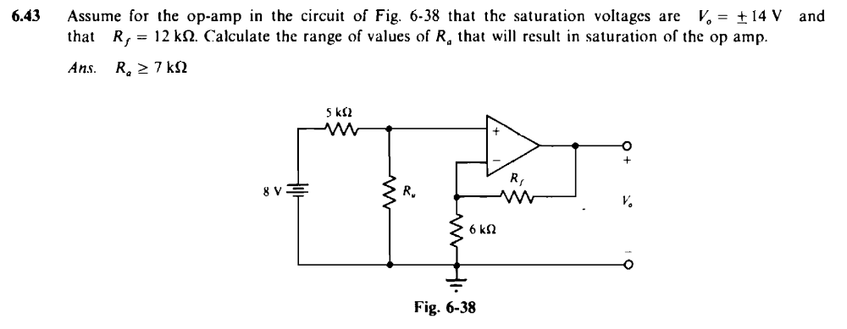

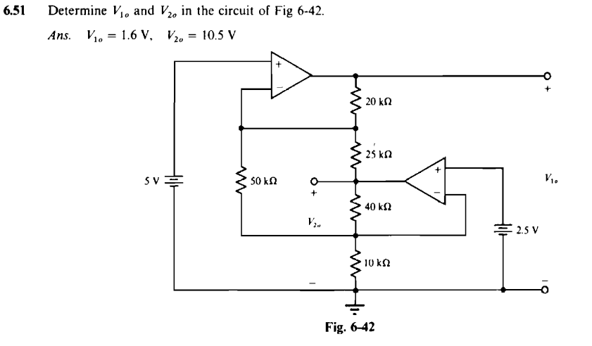

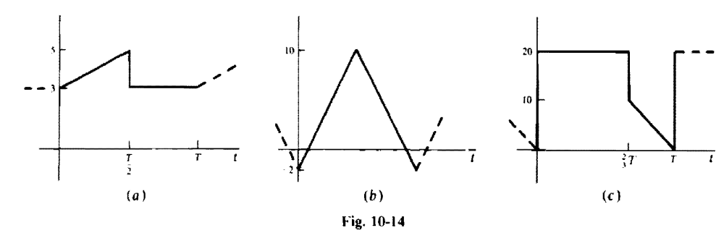

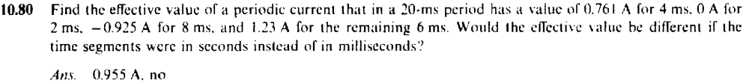

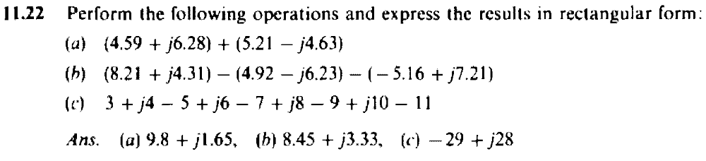

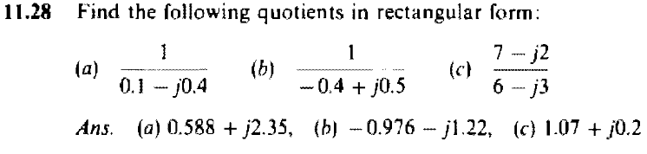

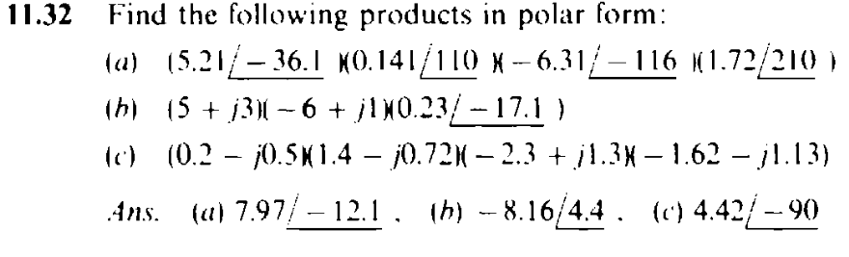

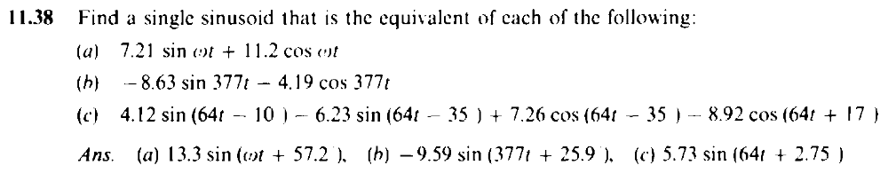

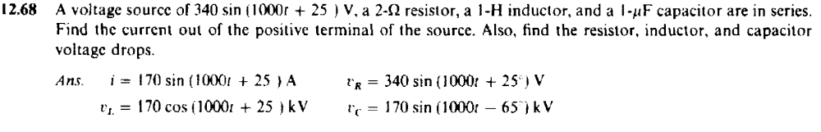

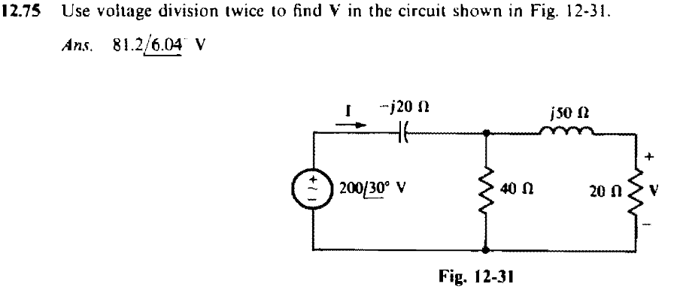

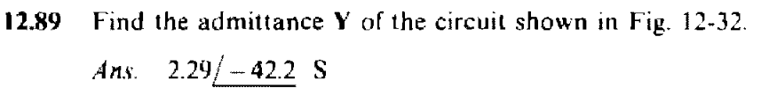

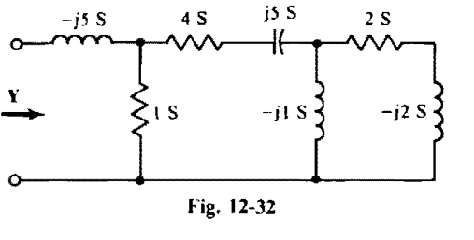

2.36 Laboratory data for a Si diode described by (2.1) show that iD = 2mA when vD =0:6V, and iD =10mA for
vD = 0:7V. Find (a) the temperature for which the data were taken, and (b) the reverse saturation
current.
Ans: ðaÞ 87:198C; ðbÞ 2:397_A

2.41 Find the power dissipated in the load resistor RL = 100_ of the circuit of Fig. 2-22(a) if the diode is ideal
and vS = 10 sin wt V. Ans: 206:6mW

2.43 The logic AND gate of Fig. 2-46(a) is to be used to generate a crude pulse train by letting v1 ¼ 10 sin !tV
and v2 ¼ 5V. Determine (a) the amplitude and (b) the period of the pulse train appearing as vo.
Ans: ðaÞ 5V; ðbÞ 2_=!

3.41 In the circuit of Fig. 3-13, VCC ¼ 20V;RC ¼ 5k_;RE ¼ 4k_, and RB ¼ 500 k_. The Si transistor has
ICBO ¼ 0 and _ ¼ 50. Find ICQ and VCEQ. Ans: 1:91 mA, 2.64V
3.42 The transistor of Problem 3.41 failed and was replaced with a new transistor with ICBO ¼ 0 and _ ¼ 75. Is
the transistor still biased for active-region operation?
Ans. Since the calculated VCEQ ¼ _6:0V < 0, the transistor is not in the active region.
3.43 What value of RB will result in saturation of the Si transistor of Fig. 3-13 if VCC ¼ 20 V, RC ¼ 5k_,
RE ¼ 4k_; _ ¼ 50, and VCEsat ¼ 0:2V? Ans: RB 442:56 k_

3.44 The circuit of Fig. 3-29 illustrates a method for biasing a CB transistor using a single dc source. The
transistor is a Si device ðVBEQ ¼ 0:7VÞ, _ ¼ 99, and IBQ ¼ 30 _A. Find (a) R2, and (b) VCEQ.
Ans: ðaÞ 3:36 k_; ðbÞ 6:06V

